1. How to obtain time series real-world renewable data

Check here for solar farm locations: <https://www.google.com/maps/d/edit?mid=1A304EE4053fggmYtFxrWVrOwzvQz72A&usp=sharing>

Check here for wind farm locations:

<https://eerscmap.usgs.gov/uswtdb/viewer/#3/37.25/-96.25>

The first step is to select the renewable energy generation that is needed. This is done by projecting the locations of renewable energy generation on the IEEE 118 bus system.

The 2 csv file contain raw data (here I just attached 45 days) on the time series of renewable energy generation output. The two .py files are to get selected generation data.

1. How to obtain time series load data

The CSV file named “Native_Load_2023” contains time series load data. Since it only has one load profile for one zone, we can add noise to it to create multiple load profiles.

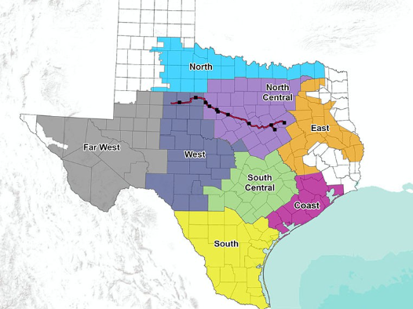

1. We can project the IEEE 118 bus system to the ERCOT area, choosing PV and wind corresponding to the load area.